**Martingale Residual Plot**

**Macro Name:** MPLOT

**Created Date/Author:** Feb. 2012 /Yuan Liu

**Last Update Date/Person:** June 7, 2014/Dana Nickleach

**Current Version**: V13

**Working Environment:** SAS 9.3 English version

**Contact**: Dr. Yuan Liu [yliu31@emory.edu](mailto:yliu31@emory.edu)

**Purpose:** To produce martingale residual plot for a continuous variable to predict time to event outcome. This plot will help to detect any nonlinear relationship, as well as to choose the meaningful cut point to categorize a numerical variable.

**Notes:** The graph will be saved in a Word document.

**Parameters:**

|  |  |
| --- | --- |
| **Macro variable** | **Description** |
| DS | The name of the data set to be analyzed. |
| TIME | Time to event outcome variable. |
| STAT | The variable name for censoring indicator. **It is required that 1 is used for the event and 0 for censored cases.** |
| CUTVAR | The numerical variable to be plotted. The variable name cannot be more than 26 characters. |
| SM | Smoothing parameter. The default value is 0.65. |
| TICK | X-axis major tick mark unit (optional). Note that if the unit is very small, a larger unit may be chosen that is a multiple of the supplied number to prevent too many tick marks. |
| HREF | Set to T for a horizontal reference line at zero (optional). The default value is F. |
| VREF | Values where vertical reference lines should appear separated by spaces (optional). |
| VREFLABEL | Labels to use for vertical reference lines (optional). Each label should be in quotes and multiple labels should be separated by a space. The order of the labels needs to correspond to the VREF parameter. |
| VREFCOLOR | Colors to use for each vertical reference lines separated by a space (optional). The order of the colors needs to correspond to the VREF parameter. By default all lines will be in blue. |
| VREFTHICK | Line thickness in pixels to use for each vertical reference lines separated by a space (optional). The order of the thicknesses needs to correspond to the VREF parameter. |
| VREFPATT | Line pattern to use for each vertical reference lines separated by a space (optional). The order of the patterns needs to correspond to the VREF parameter. By default a different line pattern will be used for each reference line. |
| SUBTIT | Text to be added to the title to appear after, but on the same line as the first title (optional). Text should not be enclosed in quotes. By default no additional text will be printed. |
| SUBTIT2 | Text to be used for a subtitle to appear under the main title (optional). Text should not be enclosed in quotes. By default no subtitle will be printed. |
| DEC | Fixed number of decimal places to display in the percentile table (optional). Note that the maximum format width is 7. So the number of decimal places can't be more than 5, but depending on the size of the numbers may be less. The best format is used by default. |
| DOC | Set to T to create a RTF file containing the output or F to suppress creation of the RTF file (optional). The default value is T. |
| OUTPATH | File path for output table to be stored. |
| FNAME | File name for output table. |
| DEBUG | Set to T if running in debug mode (optional). Work datasets will not be deleted in debug mode. This is useful if you are editing the code or want to further manipulate the resulting data sets. The default value is F. |

**Usage Example:**

**DATA** analysis;

input id os_censor Sex $ Age duration os progress $ trt $;

LABEL os = 'Overall Survival (months)'

progress = 'Progression'

trt = 'Treatment'

duration = 'Duration of Radiation';

DATALINES;

1 1 M 40 44 20 No B

2 1 F 45 46 16 Yes A

3 1 F 40 32 20 No B

4 1 F 47 32 23 No B

5 0 M 41 25 22 No B

6 1 M 54 35 13 No B

7 1 M 48 50 9 Yes A

8 1 M 36 33 12 Yes B

9 0 F 49 51 8 Yes A

10 1 M 49 52 10 Yes A

11 1 M 44 35 12 No A

12 1 M 49 50 8 Yes A

13 1 M 44 44 14 Yes A

14 1 M 50 31 10 Yes A

15 1 M 53 40 15 No B

16 0 M 52 29 20 Yes B

17 1 F 46 45 5 Yes A

18 1 F 37 44 11 Yes A

19 1 M 49 46 13 No B

20 1 M 42 31 11 No A

;

TITLE 'Figure 1 Martingale Residual Plot';

%MPLOT(ds = analysis,

time = os,

stat = os_censor,

cutvar = age,

outpath = C:\Documents and Settings\User\My Documents\,

fname = Figure 1 Martingale Residual Plot);

TITLE;

**Summary Table Example:**

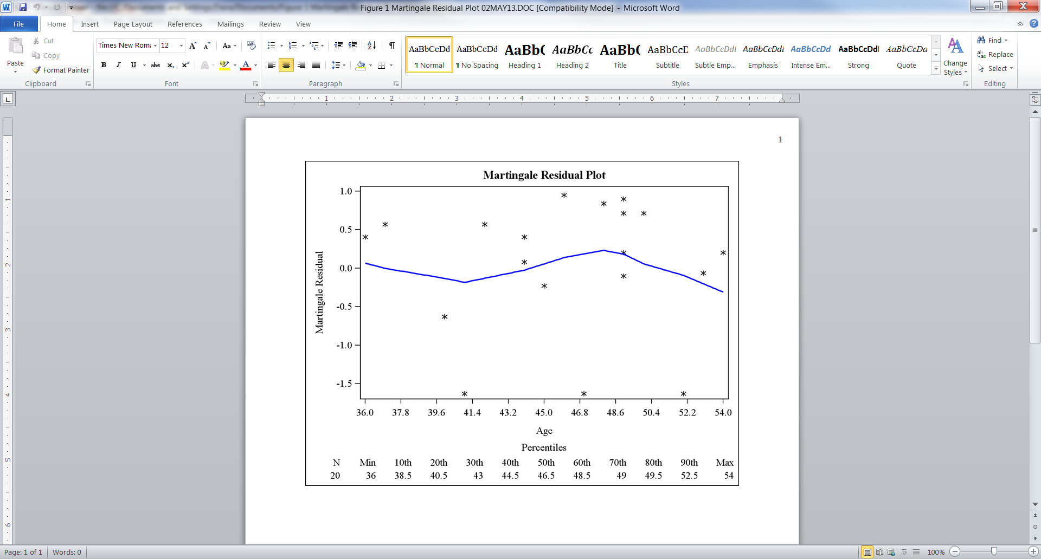

**Permission:**

Permission is hereby granted, free of charge, to any person obtaining a copy of this software and associated documentation files (the "Software"), to deal in the Software without restriction, including without limitation the rights to use, copy, modify, merge, publish, distribute, sublicense, and/or sell copies of the Software, and to permit persons to whom the Software is furnished to do so, subject to the following conditions:   
  
The above copyright notice and this permission notice shall be included in all copies or substantial portions of the Software.  
  
THE SOFTWARE IS PROVIDED "AS IS", WITHOUT WARRANTY OF ANY KIND, EXPRESS OR IMPLIED, INCLUDING BUT NOT LIMITED TO THE WARRANTIES OF MERCHANTABILITY, FITNESS FOR A PARTICULAR PURPOSE AND NONINFRINGEMENT. IN NO EVENT SHALL THE AUTHORS OR COPYRIGHT HOLDERS BE LIABLE FOR ANY CLAIM, DAMAGES OR OTHER LIABILITY, WHETHER IN AN ACTION OF CONTRACT, TORT OR OTHERWISE, ARISING FROM, OUT OF OR IN CONNECTION WITH THE SOFTWARE OR THE USE OR OTHER DEALINGS IN THE SOFTWARE.

**Log of Updates:**

|  |  |  |  |
| --- | --- | --- | --- |
| **Date** | **By** | **Description** | **Version** |
| 8/7/12 | Dana Nickleach ([dnickle@emory.edu](mailto:dnickle@emory.edu)) | Prevented deletion of temporary data sets not created by the macro and added restoration of original options at the end of the macro. | V2 |
| 8/24/12 | Dana Nickleach ([dnickle@emory.edu](mailto:dnickle@emory.edu)) | Removed proc loess and proc means output from RTF file. | V3 |
| 9/11/12 | Dana Nickleach ([dnickle@emory.edu](mailto:dnickle@emory.edu)) | Added debug and tick options. | V4 |
| 9/12/12 | Dana Nickleach ([dnickle@emory.edu](mailto:dnickle@emory.edu)) | Trimmed title text so that it would be centered correctly. Also, adjusted max axis value for tick option. Removed unnecessary merge. Removed extra space in file name. | V4 |
| 10/15/12 | Dana Nickleach ([dnickle@emory.edu](mailto:dnickle@emory.edu)) | Added check for the parameter, cutvar, being too long. | V5 |
| 10/22/12 | Dana Nickleach ([dnickle@emory.edu](mailto:dnickle@emory.edu)) | Prevented case sensitivity of T/F parameters. | V6 |
| 2/8/13 | Dana Nickleach ([dnickle@emory.edu](mailto:dnickle@emory.edu)) | Added N to output, labeled percentiles in output, added noprint to proc means, added VREF parameter, changed graphics to use SGPLOT, added SUBTIT and DOC parameter, added nobodytitle and nopoctitle for ODS, fixed bug in TICK parameter, prevented printing of proc datasets, updated deletion of datasets. | V7 |
| 2/11/13 | Dana Nickleach ([dnickle@emory.edu](mailto:dnickle@emory.edu)) | Added subtit2 parameter. | V8 |
| 2/12/13 | Dana Nickleach ([dnickle@emory.edu](mailto:dnickle@emory.edu)) | Modified to print percentiles as part of graph. | V9 |
| 2/27/13 | Dana Nickleach ([dnickle@emory.edu](mailto:dnickle@emory.edu)) | Removed variable name from plot title and redefined subtit parameters so that additional text can be added to the main title, changed VREF parameter to be called HREF, added VREF, VREFLABEL, and DEC parameters, and defined macro vars as local to avoid problems when calling from other macros. | V10 |
| 4/10/13 | Dana Nickleach ([dnickle@emory.edu](mailto:dnickle@emory.edu)) | Added VREFCOLOR and VREFTHICK parameters. | V11 |
| 6/14/13 | Dana Nickleach ([dnickle@emory.edu](mailto:dnickle@emory.edu)) | Dropped observations with a missing outcome from the data set so that n would correspond to the actual number of observations used in the plot. | V12 |
| 6/7/14 | Dana Nickleach ([dnickle@emory.edu](mailto:dnickle@emory.edu)) | Changed the transparency on vertical lines so that they can be seen slightly better when overlap occurs. | V13 |